Web Technologies – Project
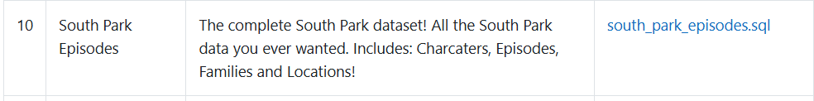
1) General description of the project
This project is a fully functional web application built around a South Park episodes database. The application has two main components:
- Front end (for all users)

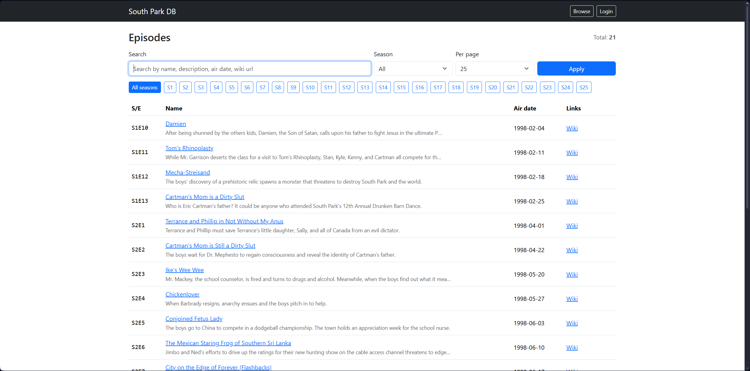

- Displays the list of episodes in a structured format.
- Supports pagination, including a selector for how many items are shown per page (e.g. 10/25/50/100).
- Provides a general search bar that searches across relevant episode fields (name, description, air date, wiki URL).
- Provides filtering controls based on relevant database fields (e.g. Season).
- Includes a details page for each episode where all available information is displayed.
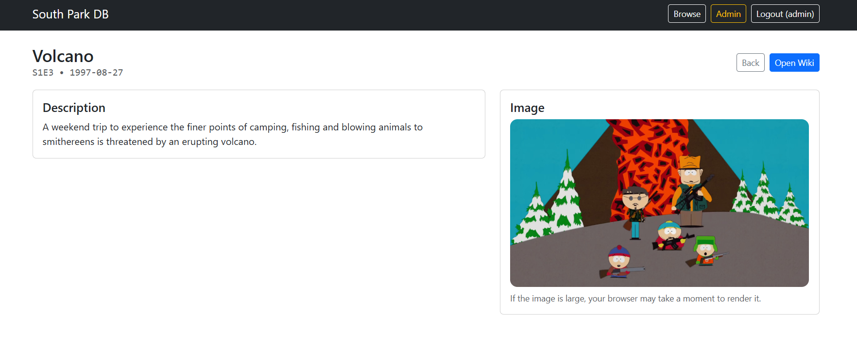
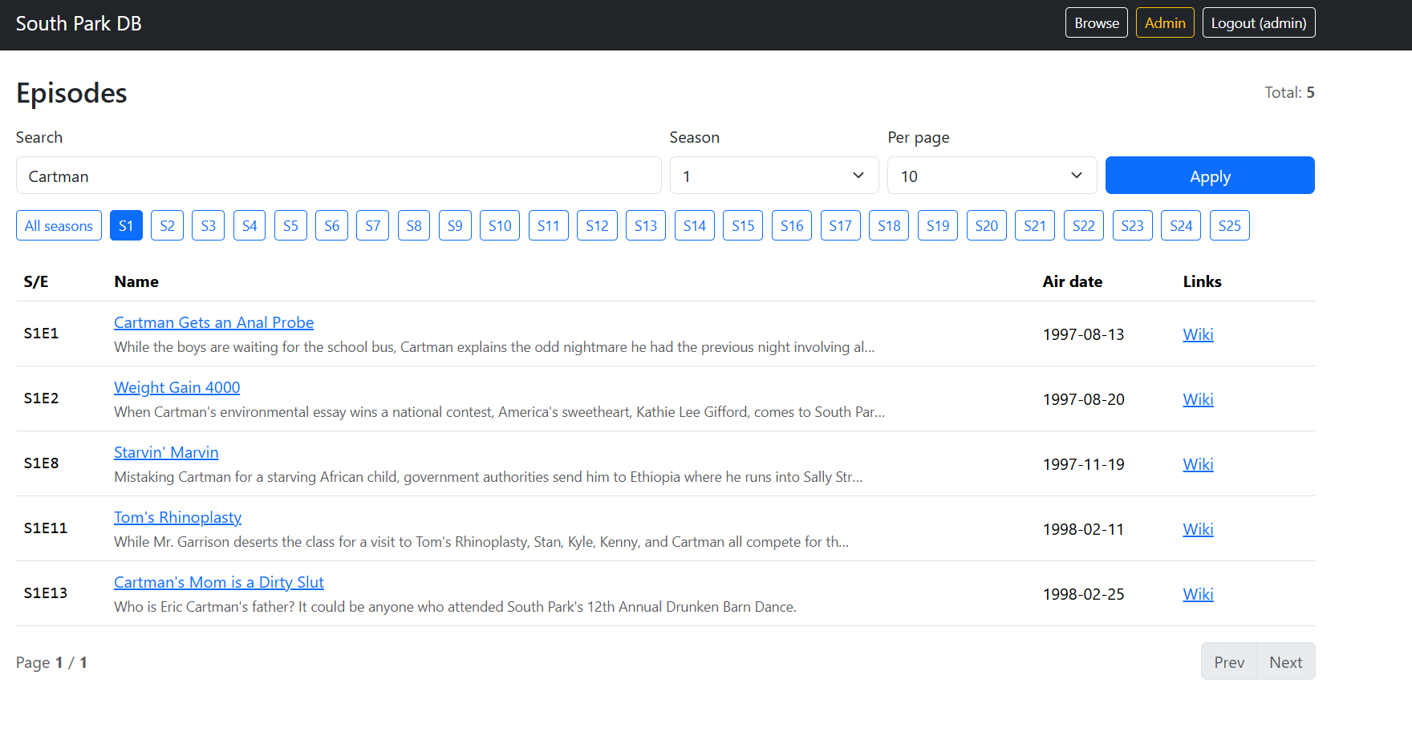
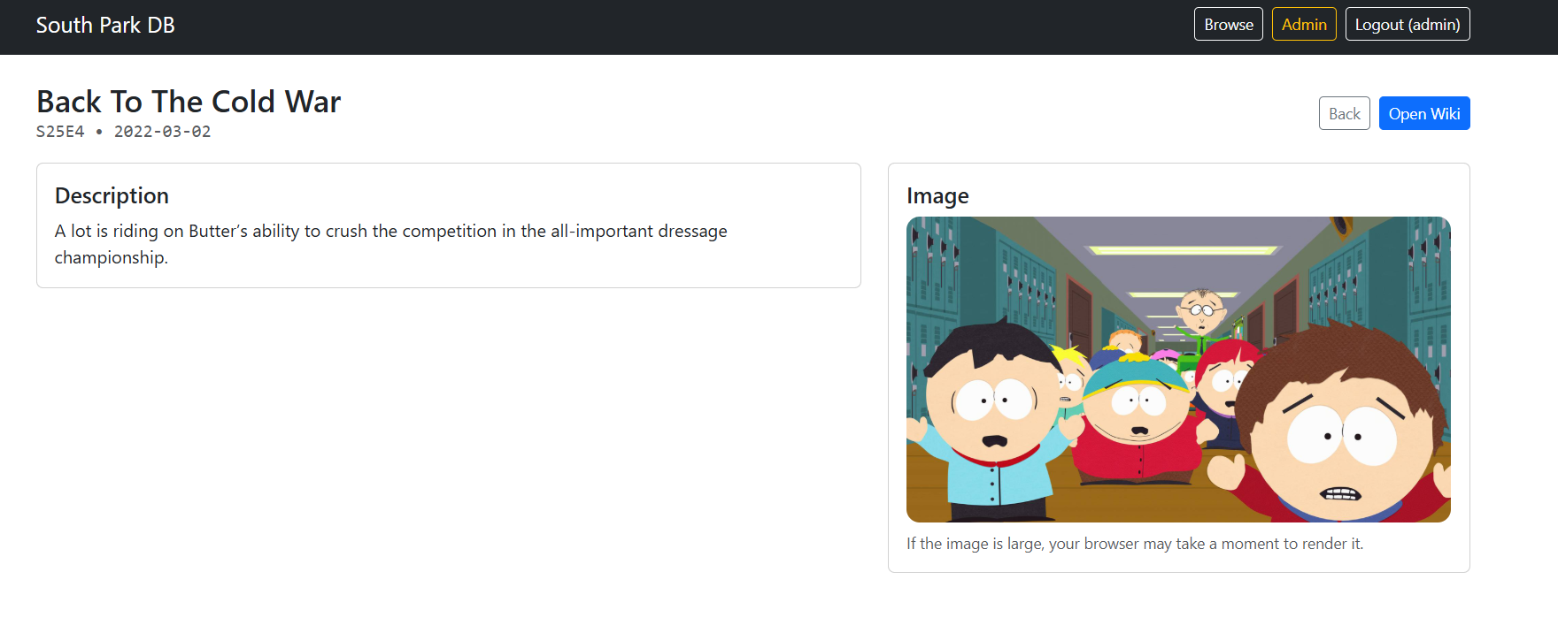
- Control Panel (Admin-only)

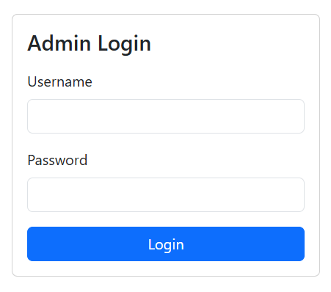

- Accessible only after authentication (admin account).
- Allows full database management:
  - Add new episodes while respecting existing data fields.
  - Edit existing episodes.
  - Delete episodes.
- This part ensures that the dataset can be maintained and updated through a friendly UI without direct database access.
The goal of the project is to demonstrate a complete web workflow: database storage, backend logic, secure admin operations, and a functional frontend with modern usability features.

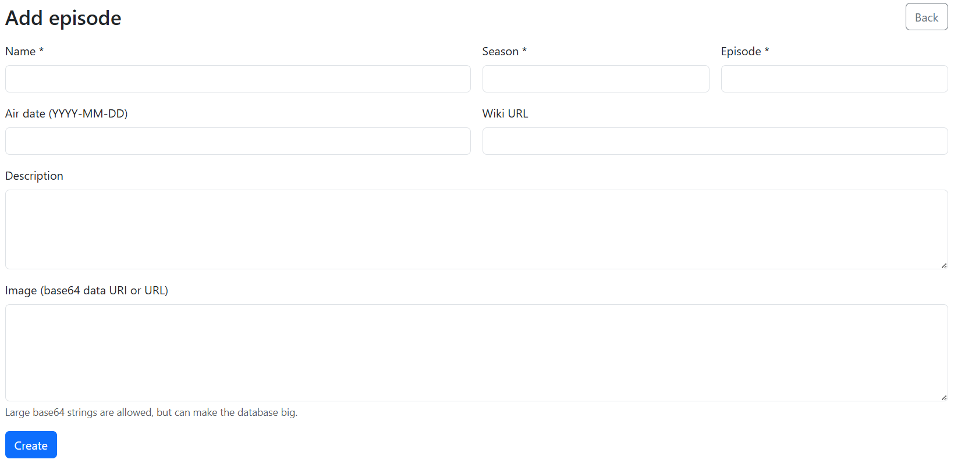
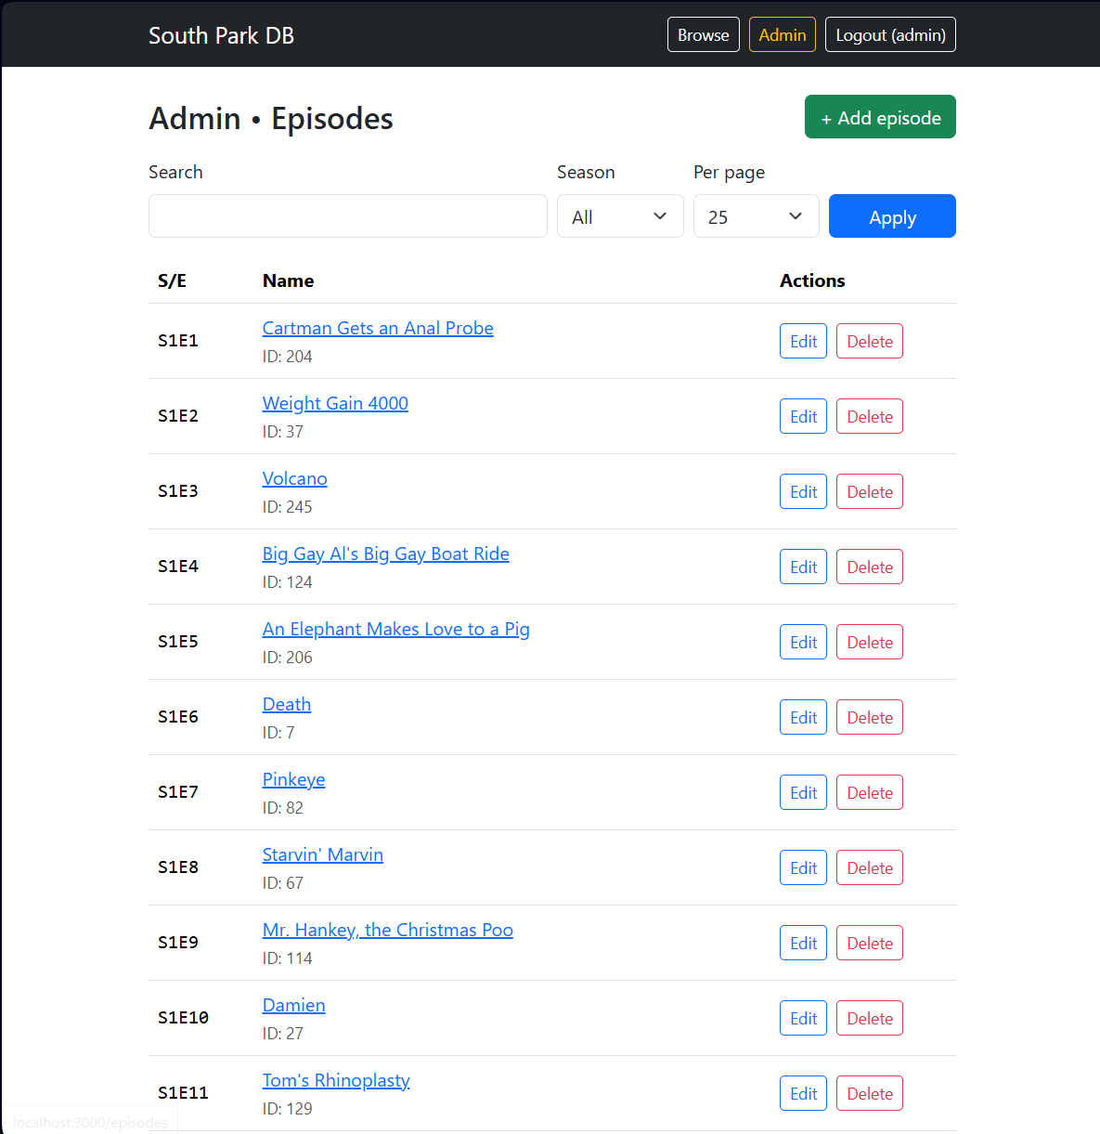
2) Technologies used
Back end
- Node.js – runtime environment used to run JavaScript on the server side.
- Express.js – backend framework used to define routes, middleware, request handling, and server logic.
- mysql2 (promise) – MySQL driver for Node.js, used for database connections and queries with async/await.

Database
- MySQL – relational database system used to store the dataset and user accounts.
- The dataset is stored in a table where episode data is kept as a JSON column, and the application extracts fields using MySQL JSON functions.
Front end
- EJS (Embedded JavaScript Templates) – server-side templating engine to generate HTML pages dynamically based on database data.
- Bootstrap – CSS framework used for responsive layout, consistent design, forms, buttons, pagination, etc.

Other helpful packages
- dotenv – loads environment variables from the .env file (DB credentials, session secret).
- method-override – enables PUT/DELETE-like operations from HTML forms (since HTML forms normally support only GET/POST).

3) Data structure – presentation of the fields in the dataset
Episodes table
The main dataset is stored in a MySQL table (example name: data) with the following columns:
- id (INT, auto increment, primary key) - Unique identifier for each episode record.
- data (JSON) - A JSON object containing the episode fields.
Inside the JSON field, each episode contains:
- name (string) – Episode title
- season (number) – Season number
- episode (number) – Episode number within the season
- air_date (string / date formatted text) – Release/air date
- wiki_url (string) – Link to the episode wiki page
- description (string) – Episode description/summary
- image (string) – Image stored as a URL or base64 data (depending on dataset)
Admin users table
The control panel uses a separate MySQL table (example: users) for authentication:
- id (INT, auto increment, primary key)
- username (VARCHAR, unique)
- password_hash (VARCHAR)
- role (ENUM / VARCHAR) – used to mark the user as admin
- created_at (TIMESTAMP)

4) Use of Artificial Intelligence – how AI was used in the project
Artificial Intelligence (AI) was used as a productivity and learning tool during development. The AI assistance helped with:
- Architecture and design decisions
- Choosing a simple but complete full-stack approach (Node.js + Express + MySQL + EJS).
- Designing a clear separation between database access, routes, and views.

- Implementation support
- Generating boilerplate code for routes, CRUD operations, and templates.
- Suggesting secure authentication practices (sessions + hashed passwords).
- Implementing features requested by the assignment: pagination, search, filters, details page, admin panel.

- Debugging and problem solving
- Diagnosing typical issues in real setups:
  - database import problems (large SQL files / images),
  - MySQL configuration errors,
  - connection credential issues,
  - server “out of sort memory” errors,
  - character sensitive search filter,
  - database queries and running
- Providing practical fixes (e.g., updating query logic, MySQL buffer settings, improving search behavior).

- Documentation assistance
- Drafting structured documentation sections (project description, technologies, data structure).
AI was not used to “replace” development, but to accelerate learning and implementation, while the final integration, testing, and deployment decisions were done by the developer.

5) Conclusions – personal conclusions, difficulties encountered, implemented solutions
Conclusions
This project demonstrates a complete working web application that includes both a user-friendly public interface and a secure admin control panel. The final version meets the required features: data browsing with pagination, searching, filtering, per-item detail pages, and full CRUD operations behind authentication.
Building this application improved understanding of:
- how a server routes requests and renders dynamic pages (Express + EJS),
- how databases are queried and how pagination/search/filtering are implemented,
- how authentication and sessions protect sensitive routes,
- how real-world debugging is part of development (DB issues, performance constraints, configuration problems).

Difficulties encountered and solutions
- Database import and large dataset
Difficulty: importing large SQL data (especially with base64 images) can be slow or fail silently in some tools.
Solution: used command-line import and verified the dataset using SELECT COUNT(*) to confirm that rows exist.

- Database connection issues
Difficulty: “Access denied for user” errors occurred when credentials or database name did not match .env.
Solution: corrected .env configuration and used a dedicated database user when needed.

- MySQL performance / sorting memory
Difficulty: encountered “Out of sort memory” caused by sorting and filtering on JSON-extracted fields.
Solution: adjusted MySQL sort settings temporarily and optimized query behavior.

- Case-insensitive search
Difficulty: search behavior depended on collation and JSON extraction.
Solution: implemented case-insensitive search using COLLATE ... _ci (or equivalent logic).

- Windows file association confusion
Difficulty: attempting to open .js files triggered Windows Script Host instead of a text editor.
Solution: opened project files using an editor (Notepad/VS Code) rather than double-click execution.

Overall, we are genuinely happy with how the project turned out. Even though we ran into several issues along the way, we managed to solve them step by step, and that process helped us understand the technologies much better. In the end, the application is functional, stable, and it covers all mandatory requirements, and we feel a real sense of progress compared to when we started.

